**Objectives**

* + String manipulation

Please submit screenshots of output this document for grading when completed.

**GitHub URL:**

**1. Vowels and Consonants**

Write a program with a function that accepts a string as an argument and returns the

number of vowels that the string contains. The application should have another function that accepts a string as an argument and returns the number of consonants that the string

contains. The application should let the user enter a string, and should display the number

of vowels and the number of consonants it contains.

**2. Most Frequent Character**

Write a program that lets the user enter a string and displays the character that appears most

frequently in the string.

**3. Word Separator**

Write a program that accepts as input a sentence in which all of the words are run together,

but the first character of each word is uppercase. Convert the sentence to a string in which

the words are separated by spaces, and only the first word starts with an uppercase letter. For

example the string “StopAndSmellTheRoses.” would be converted to “Stop and smell

the roses.”

**4. Pig Latin**

Write a program that accepts a sentence as input and converts each word to “Pig Latin.” In

one version, to convert a word to Pig Latin, you remove the first letter and place that letter

at the end of the word. Then, you append the string “ay” to the word. Here is an example:

English: I SLEPT MOST OF THE NIGHT

Pig Latin: IAY LEPTSAY OSTMAY FOAY HETAY IGHTNAY

**5. Caesar Cipher**

A “Caesar Cipher” is a simple way of encrypting a message by replacing each letter with a

letter a certain number of spaces up the alphabet. For example, if shifting the message by

13, an A would become an N, while an S would wrap around to the start of the alphabet

to become an F.

Write a program that asks the user for a message (a string) and a shift amount (an integer).

The values should be passed to a function that accepts a string and an integer as

arguments, and returns a string representing the original string encrypted by shifting the

letters by the integer. For example, a string of “BEWARE THE IDES OF MARCH” and

an integer of 13 should result in a string of “ORJNER GUR VQRF BS ZNEPU”.

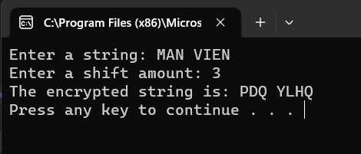

**Submit this document to Module 7 homework.**